Q-1 : What is microservices?

Ans : Microservices are the small services that work together.

Q-2 : What is monolithic architecture?

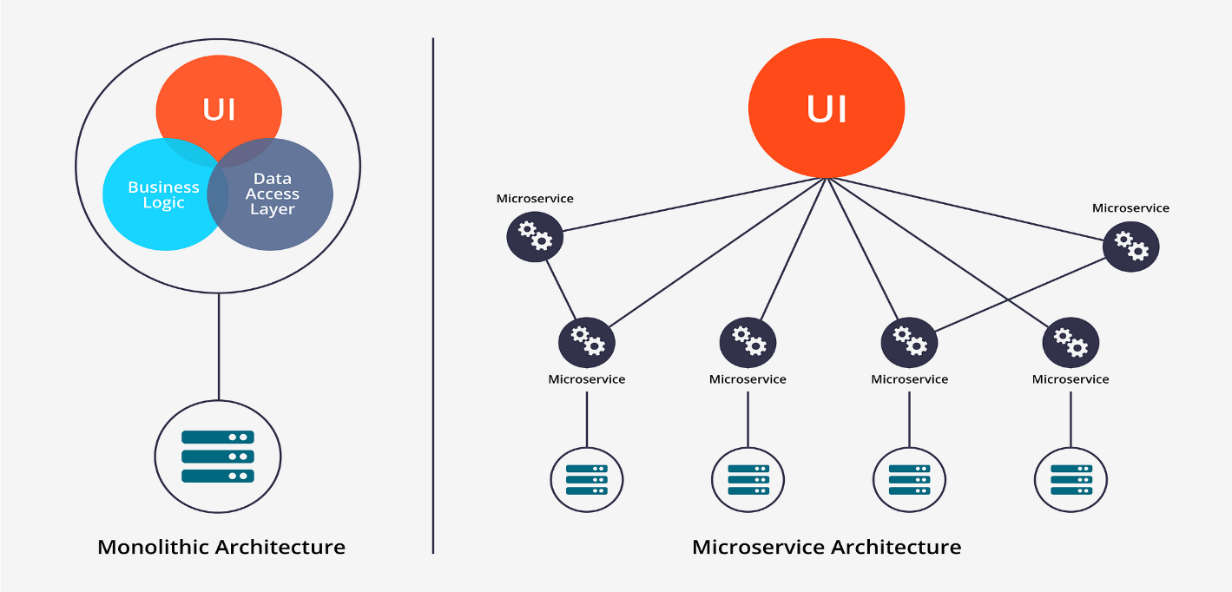Ans : all the functionalities of a project exist in a single codebase.

Q-3 : Why do we need a useEffect Hook??

Ans : to sync UI with external systems. When our component needs to do something after Rendering.

Q-4 : What is Optional Chaining?

Ans : The optional chaining ( ?. ), A safe way to access nested object properties, even if an intermediate property doesn't exist.

Q-5 : What is Optional Chaining?

Ans : The optional chaining ( ?. ), A safe way to access nested object properties, even if an intermediate property doesn't exist it will be return ‘undefined’ instead of throw error

Q-6 : What is Shimmer UI?

Ans : A shimmer UI is a version of the UI that doesn't contain actual content, but instead mimics the layout and shapes of the content that will eventually appear. It give user a sense of motion and progress.

Q-7 : [What is the difference between JS expression and JS statement?](https://www.joshwcomeau.com/javascript/statements-vs-expressions/)

Ans : An expression is a bit of JavaScript code that produces a value. A JavaScript program is a sequence of statements. Each statement is an instruction for the computer to do something.

***Note : 1. If*** *‘Console.log(/* some chunk of JS*/)’* ***runs, the code is an expression. If you get an error, it's***

***a statement (or, possibly, invalid JS).***

***2. expressions can't exist on their own. They're always part of a statement.***

***3. JSX - we can only include expressions, not statements.***

Q-8 : What is Conditional Rendering?

Ans : the process of displaying different content/UI based on certain conditions or states.

Q-9 : What is CORS?

Ans : Cross-origin resource sharing (CORS) is a standard that allows a server to relax the same-origin policy.

you need CORS when you want to pull data from external APIs that are public or authorized.

CORS defines a way for client web applications that are loaded in one domain to interact with resources in a different domain.

Q-10 : What is async and await?

Ans : keywords that can help make asynchronous code more readable.

Q-11 : What is the use of `const json = await data.json();` in getRestaurants()?

Ans : json() is a method of the Response object that allows a JSON object to be extracted from the

response. The method returns a promise, so you have to wait for the JSON.